**Identified design patterns**

Team member number:

**Patern 1 – Creational Pattern (cloning)**

Code snippet

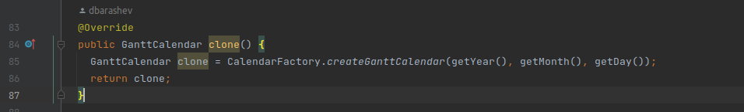

**The exact location on the codebase**

biz.ganttproject.core/src/main/java/biz/ganttproject/core/time/GanttCalendar.java

**Explanation of the rationale for identifying this as a pattern instantiation**

Creational patterns deal with cloning of objects, and although the GregorianCalendar util already has a clone method that could be used instead of this one, it is still a cloning method.

**Patern 2 – Adapter Pattern**

**Code snippet**

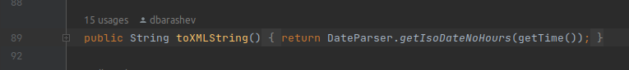

**The exact location on the codebase**

biz.ganttproject.core/src/main/java/biz/ganttproject/core/time/GanttCalendar.java

**Explanation of the rationale for identifying this as a pattern instantiation**

An adapter pattern facilitates communication between two existing systems by providing a compatible interface. Well, by parsing our calendar to an xml format, we establish this compatible interface with, for example, web pages.

**Patern 3**

Code snippet

The exact location on the codebase

Explanation of the rationale for identifying this as a pattern instantiation